.

Roxbury Congregational Church
24 Church Street ~ Roxbury, Connecticut 06783-1703

A Congregation in the United Church of Christ
“We Are a Congregation Seeking to Share God’s Love”
Office 860-355-1978 office@roxburychurch.org www.roxburychurch.org

Sunday, January 15, 2023 ~ 10:30 a.m.
Second Sunday after Epiphany

Welcome! Worship will begin soon.
No Matter Who You Are, or Where You Are on Life’s Journey, You Are Welcome Here!

If joining us virtually, we ask that you keep your microphone on MUTE for the entire service.

The Congregation at Worship
Preludes Sandra Kleisner

Greetings, Announcements and the Sharing of Prayer Concerns and Celebrations
Leader: The Peace of Christ be with you.
People: And also with you!
All for whom it is comfortable, please stand and greet one another in Christian friendship and peace.
For prayer concerns, please use first names only to protect privacy

Introit “For Behold, Darkness Shall Cover the Earth.” Handel Solo: Mark Wolmer

Call to Worship Congregation responds with words in bold.
O Lord, open our lips,
And our mouths shall declare your praise.
O Lord, open our eyes,
So that we may behold your presence.
O Lord, open our ears,
So that we may hear your call to follow.
O Lord, open our hearts,
So that we may offer you worship in love and joy.

*Hymn # 172 “We Three Kings”
(* = Stand in body or spirit)

- We three kings of orient are; bearing gifts we traverse afar, field and fountain, moor and mountain, following yonder star. O star of wonder, star of light, star with royal beauty bright, west-ward leading, still proceeding guide us to thy perfect light.

- Born a King on Bethlehem’s plain, gold I bring to crown him again, King forever, ceasing never, over us all to reign. O star of wonder, star of light, star with royal beauty bright, west-ward leading, still proceeding guide us to thy perfect light.

- Frankincense to offer have I; incense owns a Deity nigh; prayer and praising, voices raising, worshiping God on high. ‬‬‬‬
O star of wonder, star of light, star with royal beauty bright, west-ward leading, still proceeding guide us to thy perfect light.

- Myrrh is mine; its bitter perfume breathes a life of gathering gloom; sorrowing, sighing, bleeding, dying, sealed in the stone-cold tomb. O star of wonder, star of light, star with royal beauty bright, west-ward leading, still proceeding guide us to thy perfect light.

- Glorious now behold him arise; Christ and God and sacrifice: alleluia, alleluia, sounds through the earth and skies.
O star of wonder, star of light, star with royal beauty bright, west-ward leading, still proceeding guide us to thy perfect light.

Prayer of Invocation and Confession (unison)
God, our Creator and Redeemer,
your faithfulness endures forever.
You offer us new life in Christ Jesus and call us to follow him.
You challenge us to bring life and hope to the world you love.
In you we find strength and courage to face every challenge,
until the day of our Lord Jesus Christ arrives.
And so we offer our praise and gratitude to you, O God.

Faithful God,
you sent Jesus Christ to seek and save the lost
yet it’s hard to recognize we have lost our way.
We seek the next new thing instead of your gift of new life.
We follow the trends of our culture rather than Jesus’ example.
Wash over us with your cleansing Spirit,
and renew our commitment to follow your purposes revealed in Christ Jesus.
Amen.

Assurance of God’s Forgiving Love

Responsive Reading – Psalm 40:1-11 Bill Steers, Lay Reader
The Congregation is invited to respond with the words in bold.

¹Ascribe to the Lord, O heavenly beings, ascribe to the Lord glory and strength.
²Ascribe to the Lord the glory of his name; worship the Lord in holy splendor.
³The voice of the Lord is over the waters; the God of glory thunders, the Lord, over mighty waters.
⁴The voice of the Lord is powerful; the voice of the Lord is full of majesty.
⁵The voice of the Lord breaks the cedars; the Lord breaks the cedars of Lebanon.
⁶He makes Lebanon skip like a calf, and Sirion like a young wild ox.
⁷The voice of the Lord flashes forth flames of fire.
⁸The voice of the Lord shakes the wilderness; the Lord shakes the wilderness of Kadesh.
⁹The voice of the Lord causes the oaks to whirl, and strips the forest bare; and in his temple all say, “Glory!”
¹⁰The Lord sits enthroned over the flood; the Lord sits enthroned as king forever.
¹¹May the Lord give strength to his people! May the Lord bless his people with peace!

Anthem “Love Came Down at Christmas” John Rutter Choir

Scripture John 1:29-42 New Revised Standard Version

⁹The next day he saw Jesus coming toward him and declared, “Here is the Lamb of God who takes away the sin of the world! ³⁰This is he of whom I said, ‘After me comes a man who ranks ahead of me because he was before me.’ ³¹I myself did not know him; but I came baptizing with water for this reason, that he might be revealed to Israel.” ³²And John testified, “I saw the Spirit descending from heaven like a dove, and it remained on him. ³³I myself did not know him, but the one who sent me to baptize with water said to me, ‘He on whom you see the Spirit descend and remain is the one who baptizes with the Holy Spirit.’ ³⁴And I myself have seen and have testified that this is the Son of God.” ³⁵The next day John again was standing with two of his disciples, ³⁶and as he watched Jesus walk by, he exclaimed, “Look, here is the Lamb of God!”
³⁷The two disciples heard him say this, and they followed Jesus. ³⁸When Jesus turned and saw them following, he said to them, “What are you looking for?” They said to him, “Rabbi” (which translated means Teacher), “where are you staying?” ³⁹He said to them, “Come and see.” They came and saw where he was staying, and they remained with him that day. It was about four o’clock in the afternoon. ⁴⁰One of the two who heard John speak and followed him was Andrew, Simon Peter’s brother. ⁴¹He first found his brother Simon and said to him, “We have found the Messiah” (which is translated Anointed). ⁴²He brought Simon to Jesus, who looked at him and said, “You are Simon son of John. You are to be called Cephas” (which is translated Peter).

Sermon Rev. David F. Peters

Pastoral Prayer, Silent Prayer and Lord’s Prayer
Our Father, who art in heaven, hallowed be Thy Name. Thy Kingdom come, Thy will be done, on earth as it is in Heaven. Give us this day our daily bread and forgive us our trespasses as we forgive those who trespass against us. And lead us not into temptation, but deliver us from evil. For thine is the Kingdom, and the Power, and the Glory forever. Amen

Sharing Our Gifts for the Work of Christ’s Church
For those joining us online, you are invited to go to roxburychurch.org/give
for easy and secure giving, or mail donations to the church office.
Invitation to Generosity
Offertory Music
*Doxology Hymnal # 46: (stand in body or spirit)
Praise God from Whom all blessings flow. Praise Him all creatures here below. Praise Him above ye heavenly host. Praise Father, Son and Holy Ghost. Amen.
OR Praise God from whom all blessings flow; Praise God all creatures here below; Praise God for all that love has done; Creator, Christ and Spirit, One. Amen.

*Prayer of Dedication

*Hymn # 167 “Go tell it on the Mountain”

REFRAIN Go, tell it on the mountain, over the hills and everywhere; go, tell it on the mountain, that Jesus Christ is born.

- While shepherds kept their watching o’er silent flocks by night, behold throughout the heavens there shone a holy light.
REFRAIN

- The shepherds feared and trembled, when lo! above the earth, rang out the angel chorus that hailed the Savior’s birth.
REFRAIN

- Down in a lowly manger the humble Christ was born, and God sent us salvation that blessed Christmas morn.
REFRAIN

Benediction and Choral Response: “Rise up Shepherd and Follow”

Postlude You are invited to remain seated and listen and appreciate the music and stillness

We welcome especially our guests this morning! We invite you to fill out a guest card located in the pew hymnal rack or with your smartphone camera pointed to this QR code and following the link:

You can also visit https://tinyurl.com/rccguestbook

If you have no church home, we invite you to consider making this your church home. If you are a guest from out of town or just tuning into our worship service, we wish you Godspeed and hope you enjoy your time here and even get inspired!

Our thanks to those who lead us in worship today including our Greeters, Jan & Bill Steers, with Bill as the Lay reader, our Zoom Tech, Barbara Cover. Refreshments are hosted by Susan Zappulla-Peters

To Keep in our Thoughts and Prayers – January 15, 2023
Please remember their families and caregivers as well.

Terry, Dawn, Bill, Pat, Cathy,
Family and friends of Jean Kinsella death January 10
Family and friends of Nancy Callahan – death -December 13th,

People of Haiti during times of social unrest and a cholera outbreak
The people of Ukraine and those fleeing in fear and harm’s way.
Those affected by or fearful because of COVID-19, the flu or RSV,
For refugees resettling in foreign lands including nearby New Milford.

Prayers for this week’s Mission Partner: Global Ministries - UCC

Our Mission Partners – extending your reach to share God’s Love!
This Week’s Mission Partner Highlight:
Your gifts to the church support numerous ministries. This week we highlight: Global Ministries - UCC Global Ministries is a joint witness in mission between the Christian Church (Disciples of Christ) and the United Church of Christ. Join us in our mission to receive and share the Good News of Jesus Christ by joining with global and local partners to work for justice, reconciliation and peace. http://www.globalministries.org

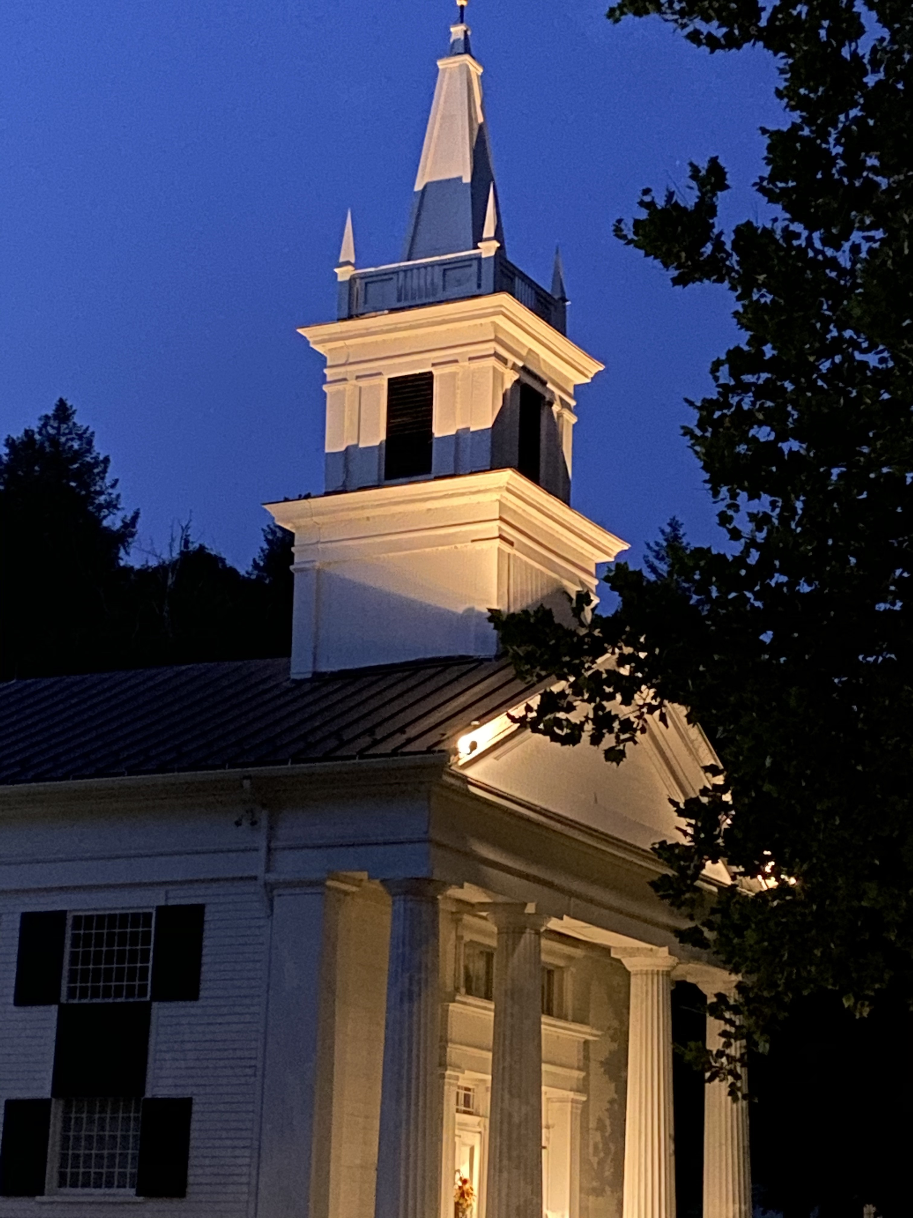
Steeple Lighting

The Steeple is lit during January

By Mike and Dottie Wilcox

In memory of his parents, Alta and Alberta Wilcox

The Steeple can be lit in loving memory of someone or in celebration of an event for a month, we ask for a donation of $25 to the Memorial Fund, contact Rev. Peters to make arrangements. We are now signing up beginning with March 2023

Want to be in the know about what is happening here at Roxbury Church? Sign up for the Church email - eFaith Matters, that are sent out most Mondays and Fridays. You can enter your email address on our church’s web homepage - roxburychurch.org.

Financial Giving for the Ministries of Roxbury Church
Open Camera
Scan Code
Give Now

Electronic Giving Give using Venmo
for offering or
Special Offerings or Memorials

Church Calendar This Week
Sunday, January 15 First Sunday after Epiphany
9:15 a.m. Choir rehearsal (Sandy Kleisner) Meetinghouse
10:30 a.m. Worship In-Person & Virtually Meetinghouse
Refreshments follow Fellowship Hall
11:45 a.m. Church Council (Brian Neff) Chapel Library

Tuesday, January 17 Rev. Peters will on his day off and out of the office
2:00 p.m. Piano lessons (Sandy Kleisner) Meetinghouse

Wednesday, January 18
6:00 p.m. Cub Scouts (Jason McKay) Hall
7:00 p.m. Boy Scout Troop 65 (Jason McKay) Hall

Saturday, January 21
10:30 a.m. Mindfulness Meditation (Charlie Stauffacher) online only

Sunday, January 22 Second Sunday after Epiphany
9:15 a.m. Choir rehearsal (Sandy Kleisner) Meetinghouse
10:30 a.m. Worship In-Person & Virtually Meetinghouse
Refreshments follow Fellowship Hall

Looking Ahead
February 12 Annual Meeting & Potluck Lunch Fellowship Hall
Hymn and Anthem Words & Music: Chalice Press,1995, used with permission. All rights reserved. Reprinted under ONE LICENSE # A- A-731919 (General and Livestreaming licenses) Selected worship liturgy from The Presbyterian Church in Canada and the United Church of Christ. The New Revised Standard Version of the Bible (NRSV), The National Council of Churches, USA.,

Roxbury Congregational Church
Ministers in the World Members of the Congregation
The Reverend David F. Peters, Minister david@roxburychurch.org
Sandra S. Kleisner, Minister of Music sandy@roxburychurch.org
Luanne Awlasewicz, Church Secretary Bruce Rossiter, Custodian

Social Media and Other Important Links
Facebook: www.facebook.com/RoxburyChurch
YouTube: https://tinyurl.com/RoxburyCyoutube
Twitter: www.twitter.com/RoxburyChurch
Instagram: http://www.instagram.com/roxburyucc
Guestbook: https://forms.gle/vEVsj9RZs1JVmfVA7
Online Offering Site https://secure.myvanco.com/L-Z252/home

Our congregation has a covenantal relationship with:
&

