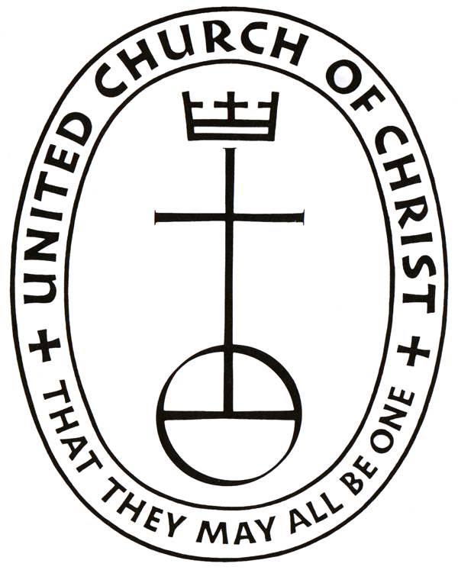
Roxbury Congregational Church
A Congregation of the United Church of Christ
24 Church Street ~ Roxbury, Connecticut 06783
860-355-1978
www.roxburychurch.org

“We Are A Community Seeking To Share God’s Love!”

The Rev. David F. Peters Sandra L. Kleisner
Minister Minister of Music
Nancy Glover
Church Secretary

Building Use Request Form

Date _____________________

Name of Group ______________________________________________________

Requested Day(s) & Time ___________________________________________

Requested Space ___________________________________________________

Leaders’ Name ______________________________________________________

Phone(s) ______________________________________________________________

Email(s) _______________________________________________________________

Fee Requested _______________ Non-Profit Group _________

It is understood that you are a guest of the church and that we will endeavor to leave the building as we found it and with all doors closed, lights turn off, cleaned up, and reporting any damage that occurs.

Leaders’ Signature _______________________________ Date _______________________

